Bronco ID: 016590769

Last Name: Palm

First Name: Linus

# Machine Learning and Its Applications (CS 4210)

## Assignment 1

## Author: Linus Palm

## Date: 01/05/2023

Task 1:

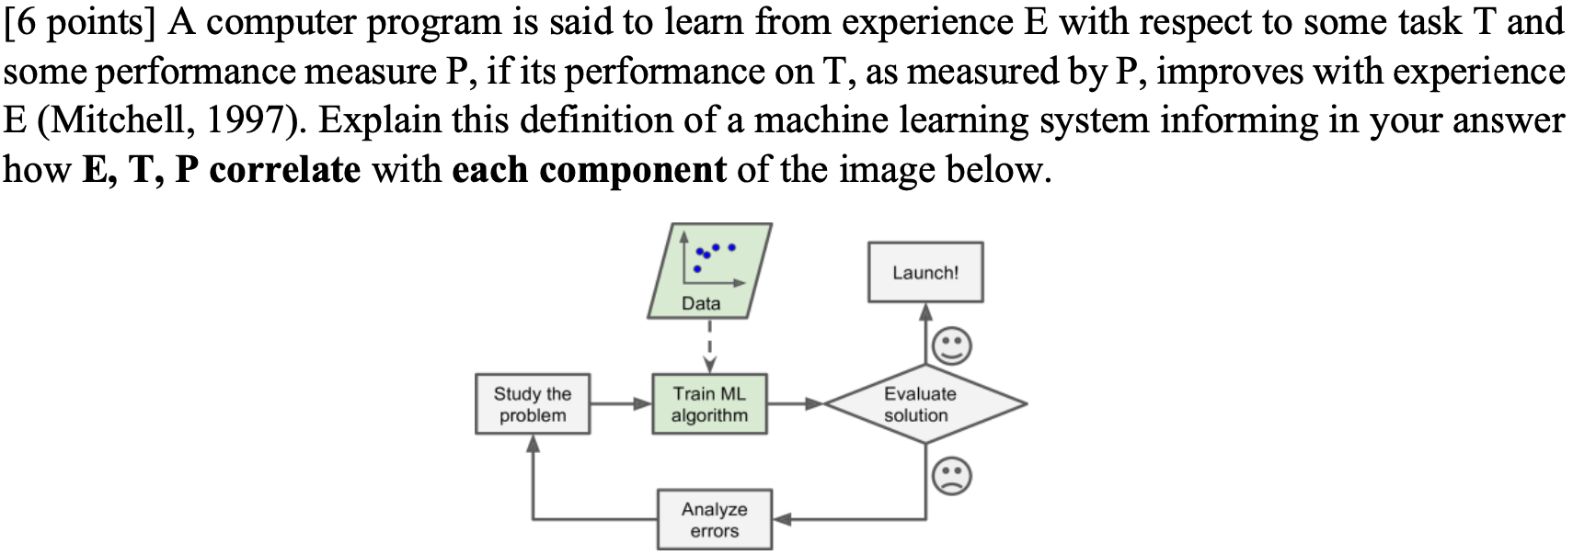

Task 2:

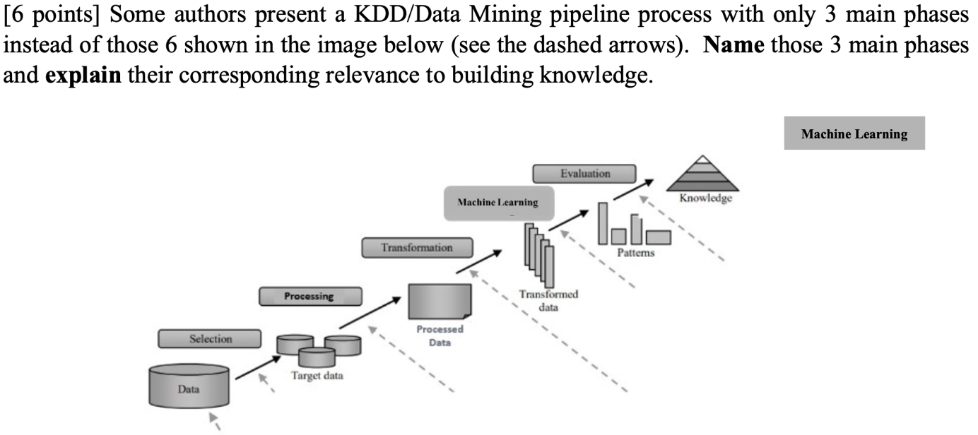

Task 3:

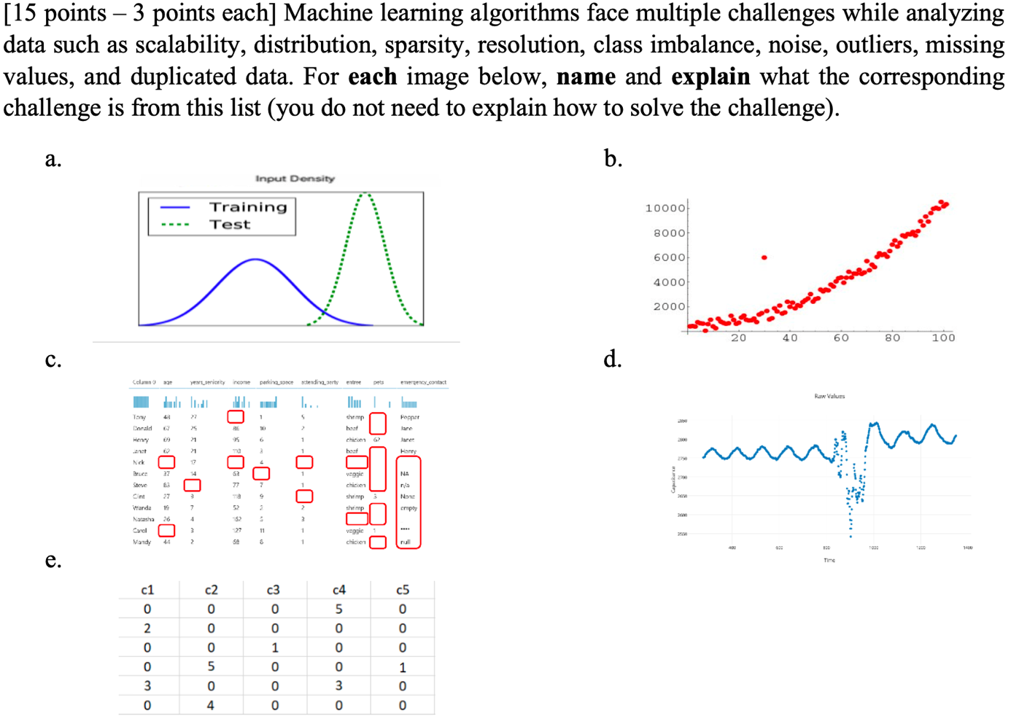

Task 4:

Ein Bild, das Tisch enthält.

1. Creating a model that can classify unseen data. For example, using a decision tree created based on the present training set.
2. In general, a feature is a property or characteristic of an object. A collection of features describes an object. The features in this dataset are “Age”, ”Spectacle Prescription”, “Astigmatism”, “Tear Production Rate” and “Recommended Lenses”. There is a column/vector for each feature in this table.
3. In general, feature values are the values that can describe the feature of an object. For example, the feature values of the feature "age" in this dataset are: “Young”, “Presbyopic” and “Prepresbyopic”.
4. In general, dimensionality is an integer value that describes the number of features that an object has. In this dataset, the dimensionality is 5 because there are five different features per object.
5. In general, an instance is an object/sample described by a collection of related features. There are 10 instances in this dataset, one per row (not including the header row).
6. In general, a class is one feature of an object used to group the objects. Our model should be able to predict this feature, i.e., the class, based on the feature values of the other features. In this dataset the class would be “Recommended Lenses”.

Task 5:

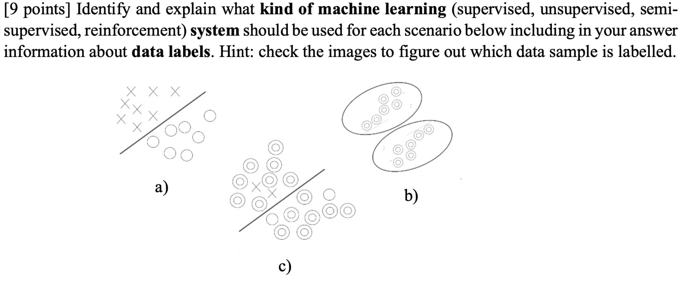

Task 6:

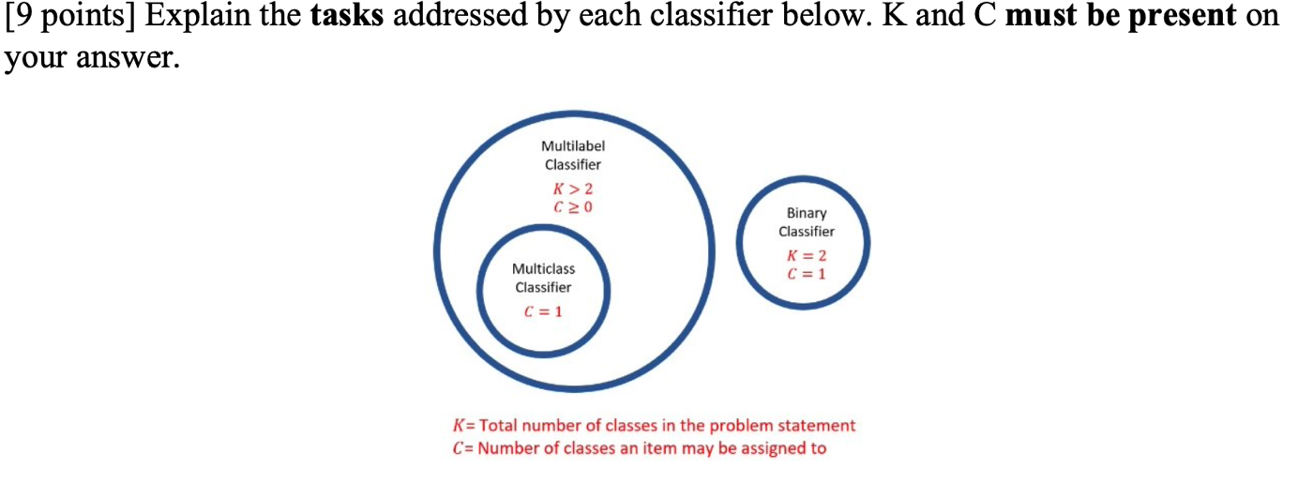

* Binary Classifier (Concept Learning): The model must learn to select one (C=1) of two (K=2) different classes to classify an object. For example, when processing a picture, it should be able to tell whether there is a dog on it or not.
* Multiclass Classifier (Multiclass Learning): The model must learn to select one (C=1) of more than two (K > 2) different classes to classify an object. For example, when processing a picture, it should be able to tell whether it shows an apple, a banana, or a peach.
* Multilabel Classifier (Multilabel Learning): The model must learn to select any number (C >= 0) of more than two (K > 2) different classes to classify an object. For example, when processing a document, it should be able to tell whether it is about science and/or sports and/or music and/or news or none of the above.

Task 7:

